**Running a react app in a docker container**

**Steps:**

1. Cloned a flask app from git `git clone https://github.com/do-community/flask_blog.git`
2. Creating a Dockerfile  
   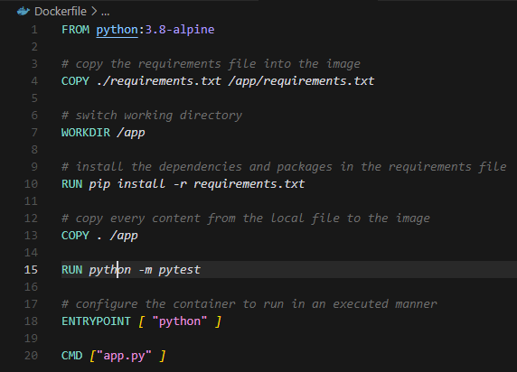
3. Creating docker-compose.yml  
   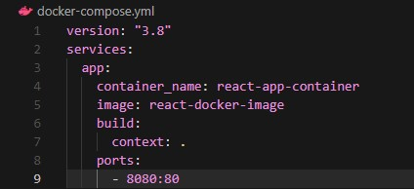
4. Running `docker compose up`  
   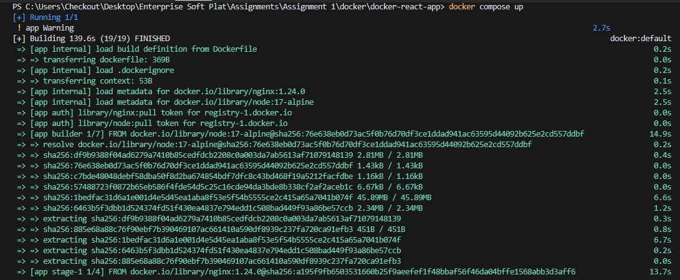
5. It can also run tests for us  
   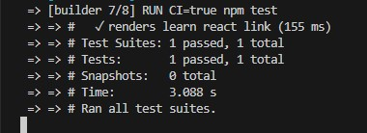
6. After step 5, the container shows up in docker desktop client  
   
7. As expected, the app us running on port 8080 as specified in `docker-compose.yml`  
   